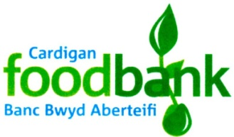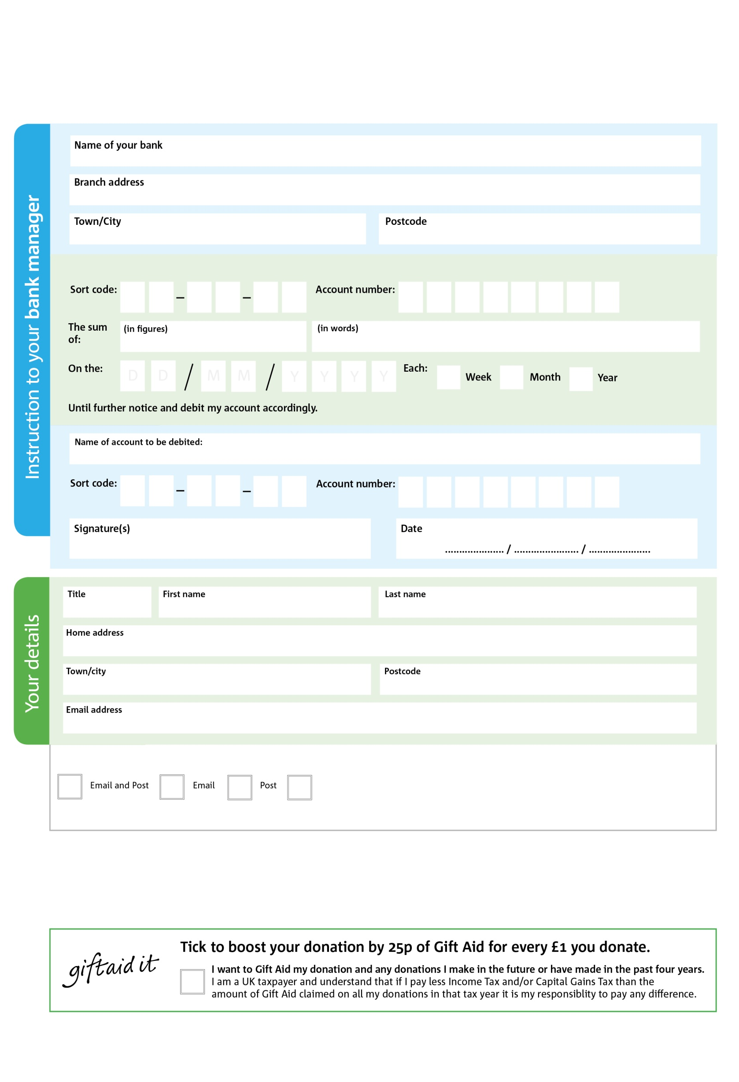

Please pay : New Life Church, Cardigan. (Ref. Cardigan Foodbank).

**Please pass this form onto the foodbank, using the foodbank’s address at the bottom, who will save a copy for their records. They will then send it on to your named bank or building society.**

3

V

5

V

4

V

2

V

6

V

6

V

0

V

3

V

1

4

8

1

0

2

We would love to keep you up to date with information about Cardigan Foodbank. Please tick your preference:

You can change your preferences any time by contacting us on 07949127307 or emailing us at info@cardigan.foodbank.org.uk

I do not wish to receive future communications from Cardigan Foodbank

**Data protection**

Cardigan Foodbank is committed to protecting your privacy and will process your personal data in accordance with current Data Protection legislation. Cardigan Foodbank collects information to keep in touch with you and supply you with information relating to our work. To unsubscribe from our newsletter, send a message to the email address with the word 'unsubscribe' in the subject line. A full data privacy statement for financial donors is available from the foodbank on request.

**Standing Order Mandate**

**www.cardigan.foodbank.org.uk**

Reg. Charity No: 1080146 | Reg. in England & Wales

POSTAL ADDRESS: Cardigan Foodbank, New Life Church, Lower Mwldan, Cardigan, SA43 1HR.

You can change your preferences any time by contacting us on XXXXXXXXXXX or emailing us at XXXX@XXXXXXXXXX.foodbank.org.uk

I do not wish to receive future communications from XXXXXX Foodbank