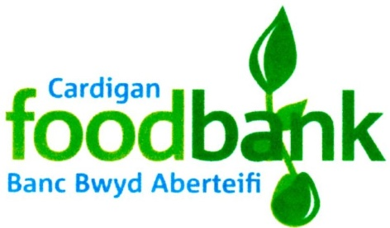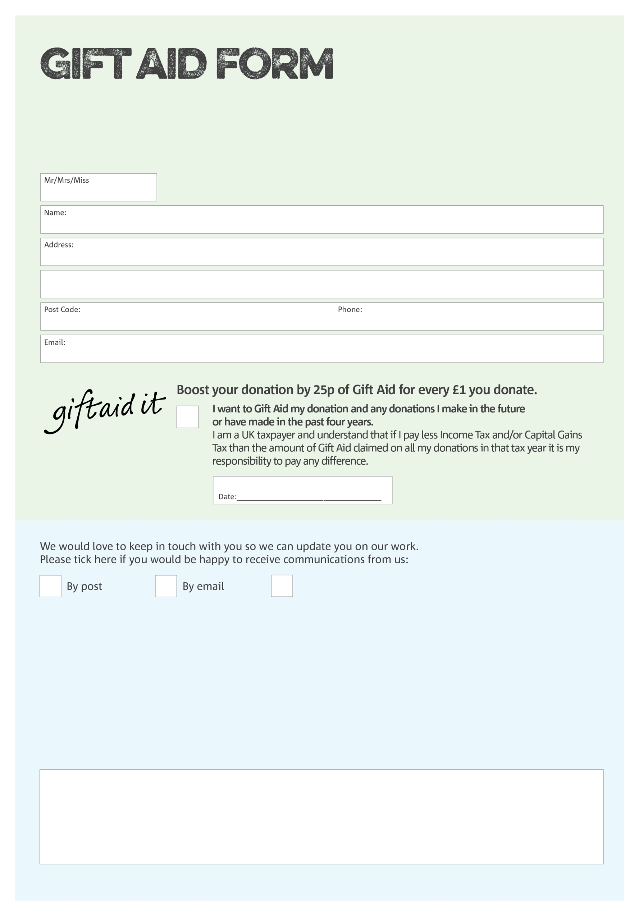

By filling in this form Cardigan Foodbank will receive an extra 25p for every £1 you give at no extra cost to you. Thank you!

I do not wish to receive future communications from Cardigan Foodbank

You can change your preferences any time by contacting us on 07949127307 or emailing us at;

info@cardigan.foodbank.org.uk

**Data protection**

Cardigan Foodbank is committed to protecting your privacy and will process your personal data in accordance with current Data Protection legislation. Cardigan Foodbank collects information to keep in touch with you and supply you with information relating to our work. To unsubscribe from our newsletter, send a message to the email address with the word 'unsubscribe' in the subject line. A full data privacy statement for financial donors is available from the foodbank on request.

We would love to know why you have chosen to donate to Cardigan Foodbank. If you would like to share your motivation let us know below:

Charity Number 1080146. Registered in England & Wales.